Environment was WSL in Windows 10.

Worked examples from:

Sobell, Mark G., and Matthew Helmke. *A Practical Guide to Linux Commands, Editors, and Shell Programming*. Addison-Wesley, 2018.

Definitely recommend the book. I previously worked from the 3rd edition in my Programming in a Unix environment with C/C++ class.

Installation:

“sudo apt update”

“sudo apt install mariadb-server”

To use MariaDB on WSL you did have to issue the following command:

“sudo /etc/init.d/mysql start”



“sudo mysql_secure_installation”

The above is recommended to remove anonymous users and set root password.

Also install the mariadb-client

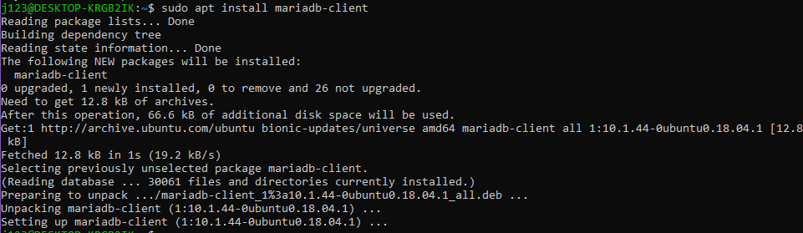

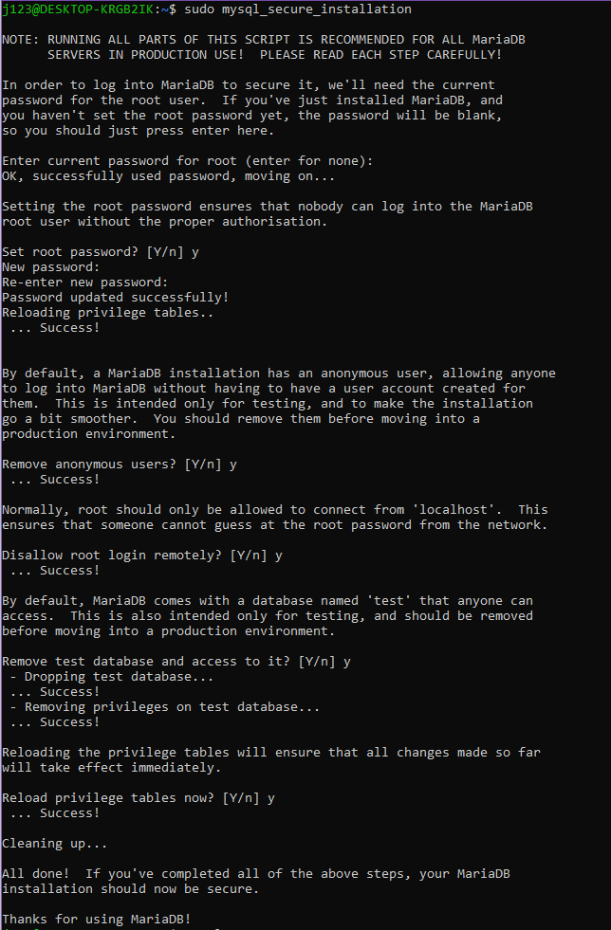

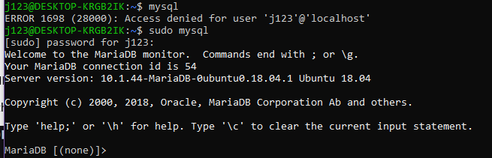

Working in WSL environment seemed to have some differences compared to working on an Ubuntu OS.

Creating a database:

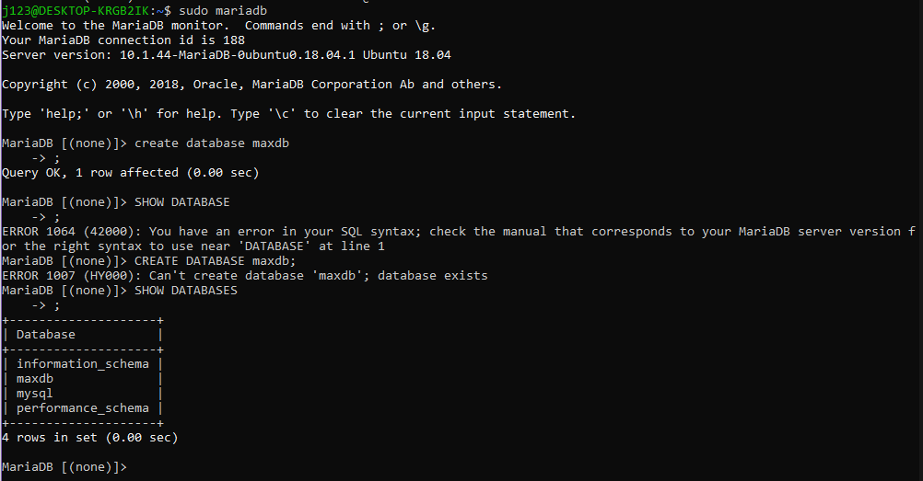

Adding a user

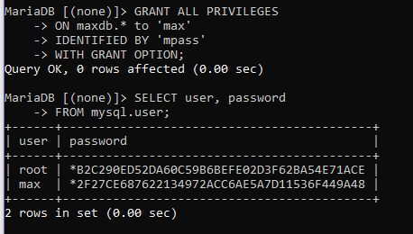

Logging in with username and password

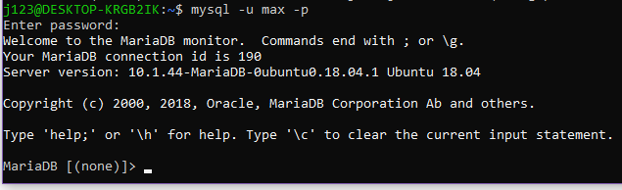

Creating a table



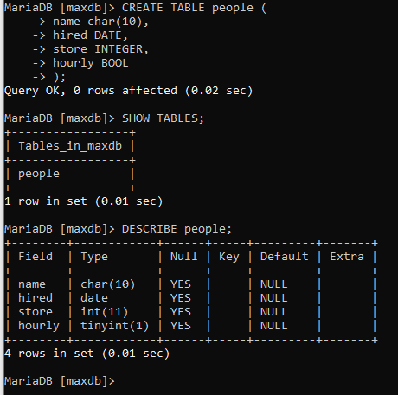

Alter table



Adding data’

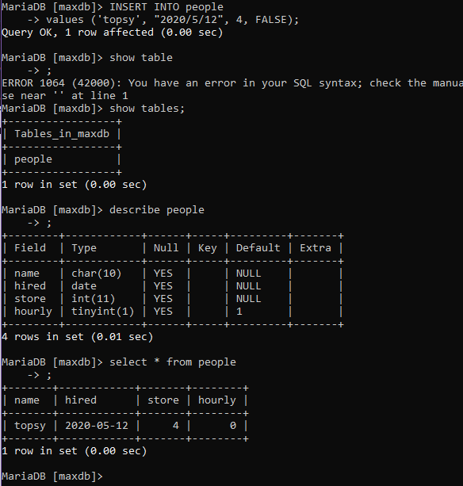

Inserting without specifying a value for all columns.

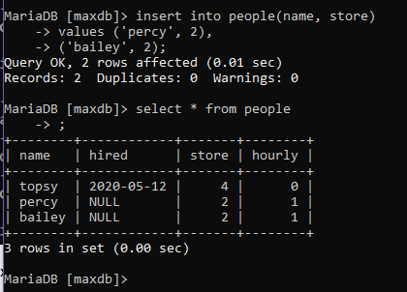

LOAD DATA LOCAL INFILE

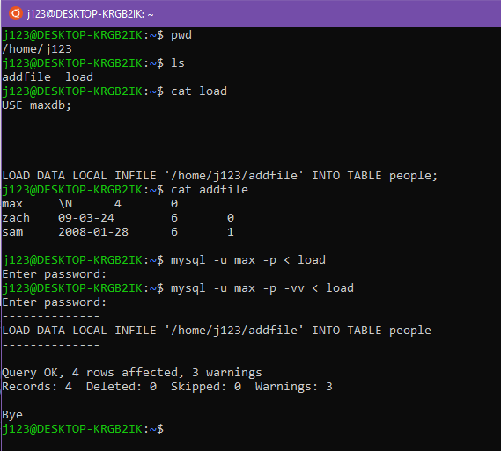

I ran it twice because I wanted to have the -v (verbose) in the text it says the more v the more verbose and I copied the books use of 2 v’s.

SELECT

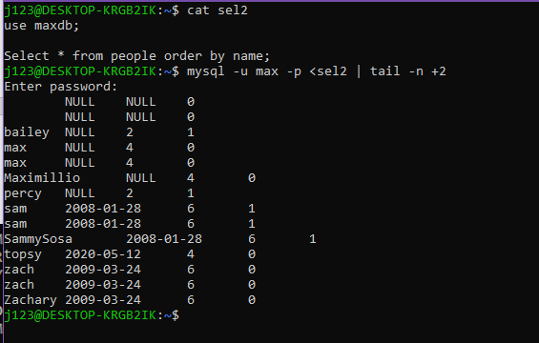

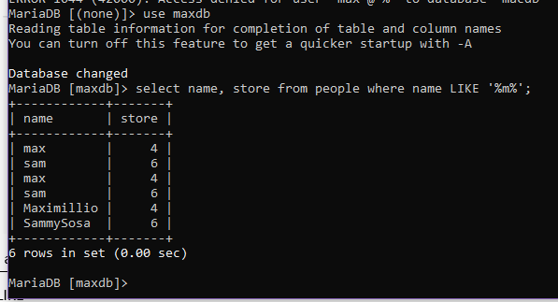

A percent sign (%) matched any string of zero or more characters and an underscore (_) matches an single character.

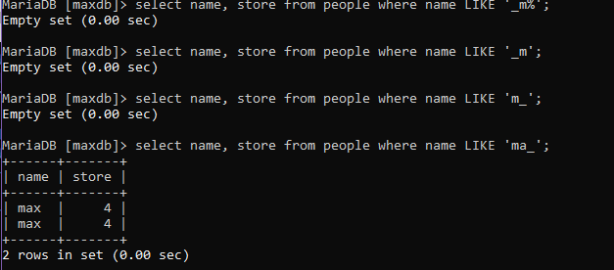

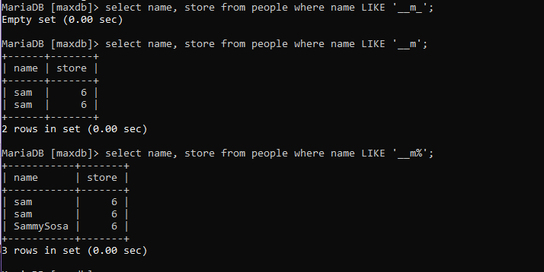

**BACKING UP A DATABASE**

*mysqldump*

Backing up a database generates a file of SQL statements that create the tables and load the data. You can then use this file to restore the database from scratch. The next example shows how Max can back up the maxdb database to a file named maxdb.bkup.sql

“mysqldump -u max -p maxdb > maxdb.bkup.sql”



Database restored to the same state as when it was backed up with the above command.

Creating a second table

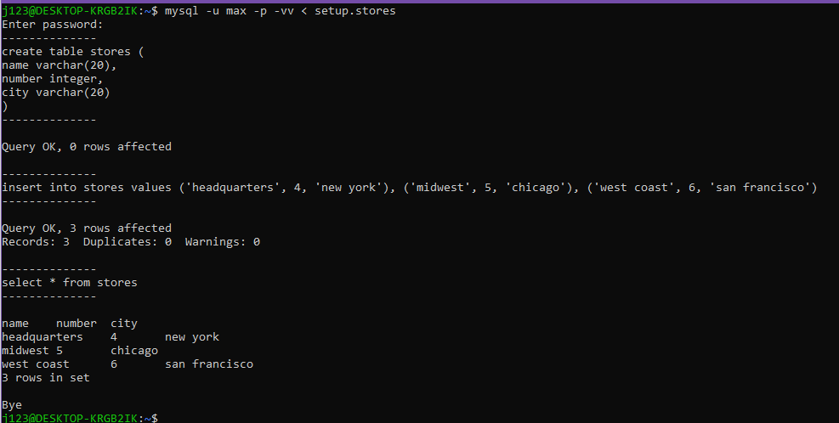

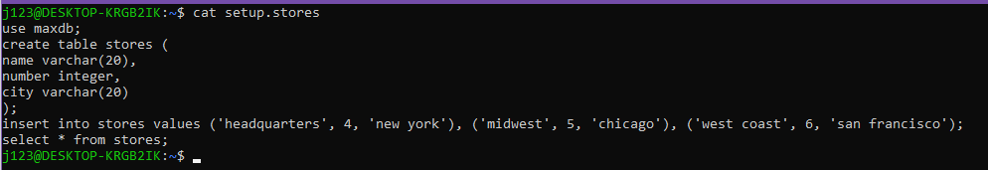

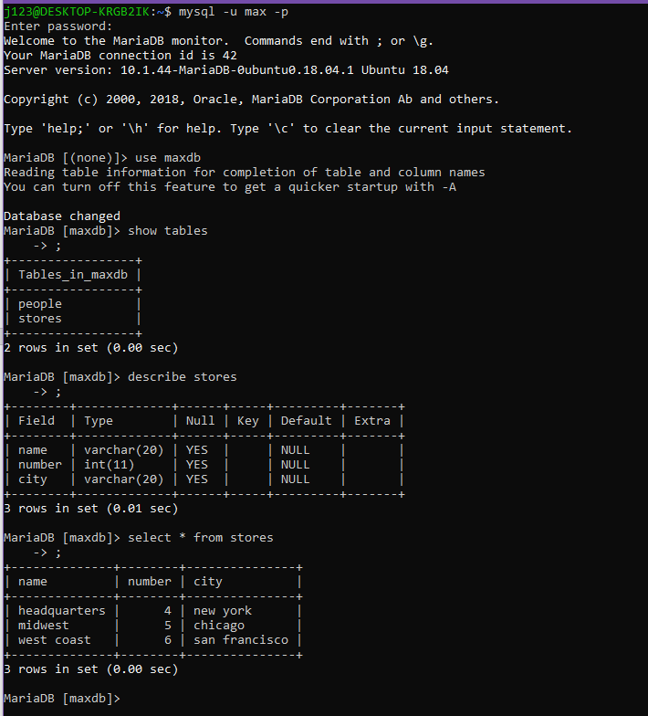

JOINS

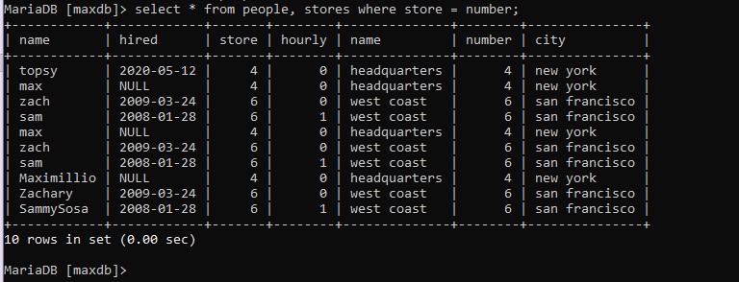

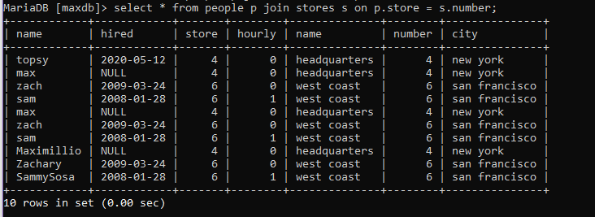

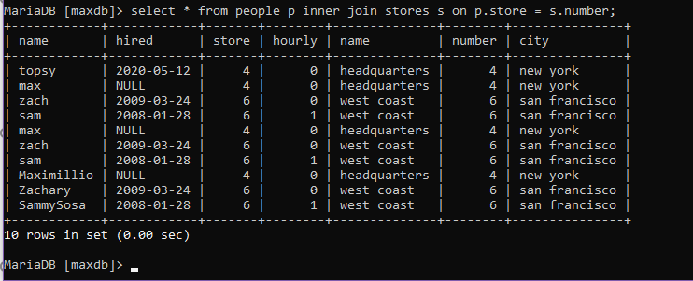

TABLE NAMES

Sometimes when working with more than one table, column names will be the same. Take for example the following statement.



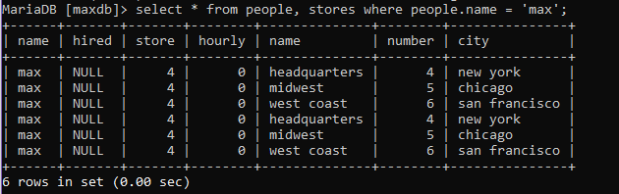

TABLE ALIASES

An alias is another usually shorter name for the table. We already saw an example of this earlier when demonstrating a join statement. Here is the example again.

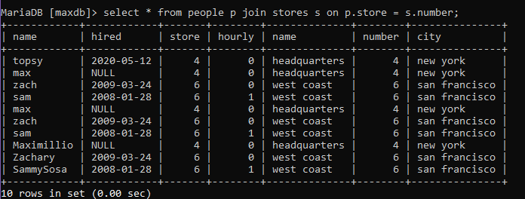

OUTER JOIN

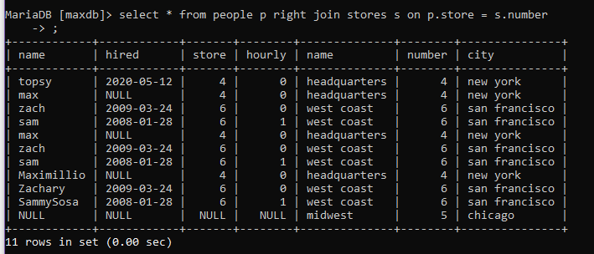

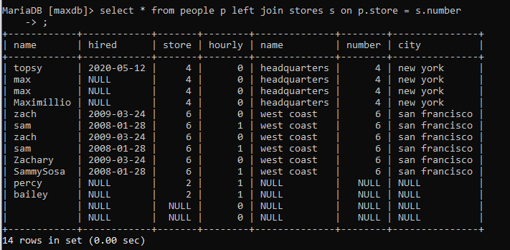

SUBQUERIES

A subquery is select clause within a where clause of another select statement. It selects from the returned value of the first select statement.

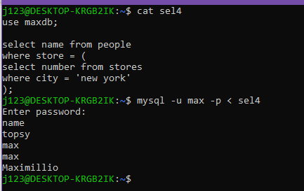

----------------------------------------

The following is a bash script from the text book.

